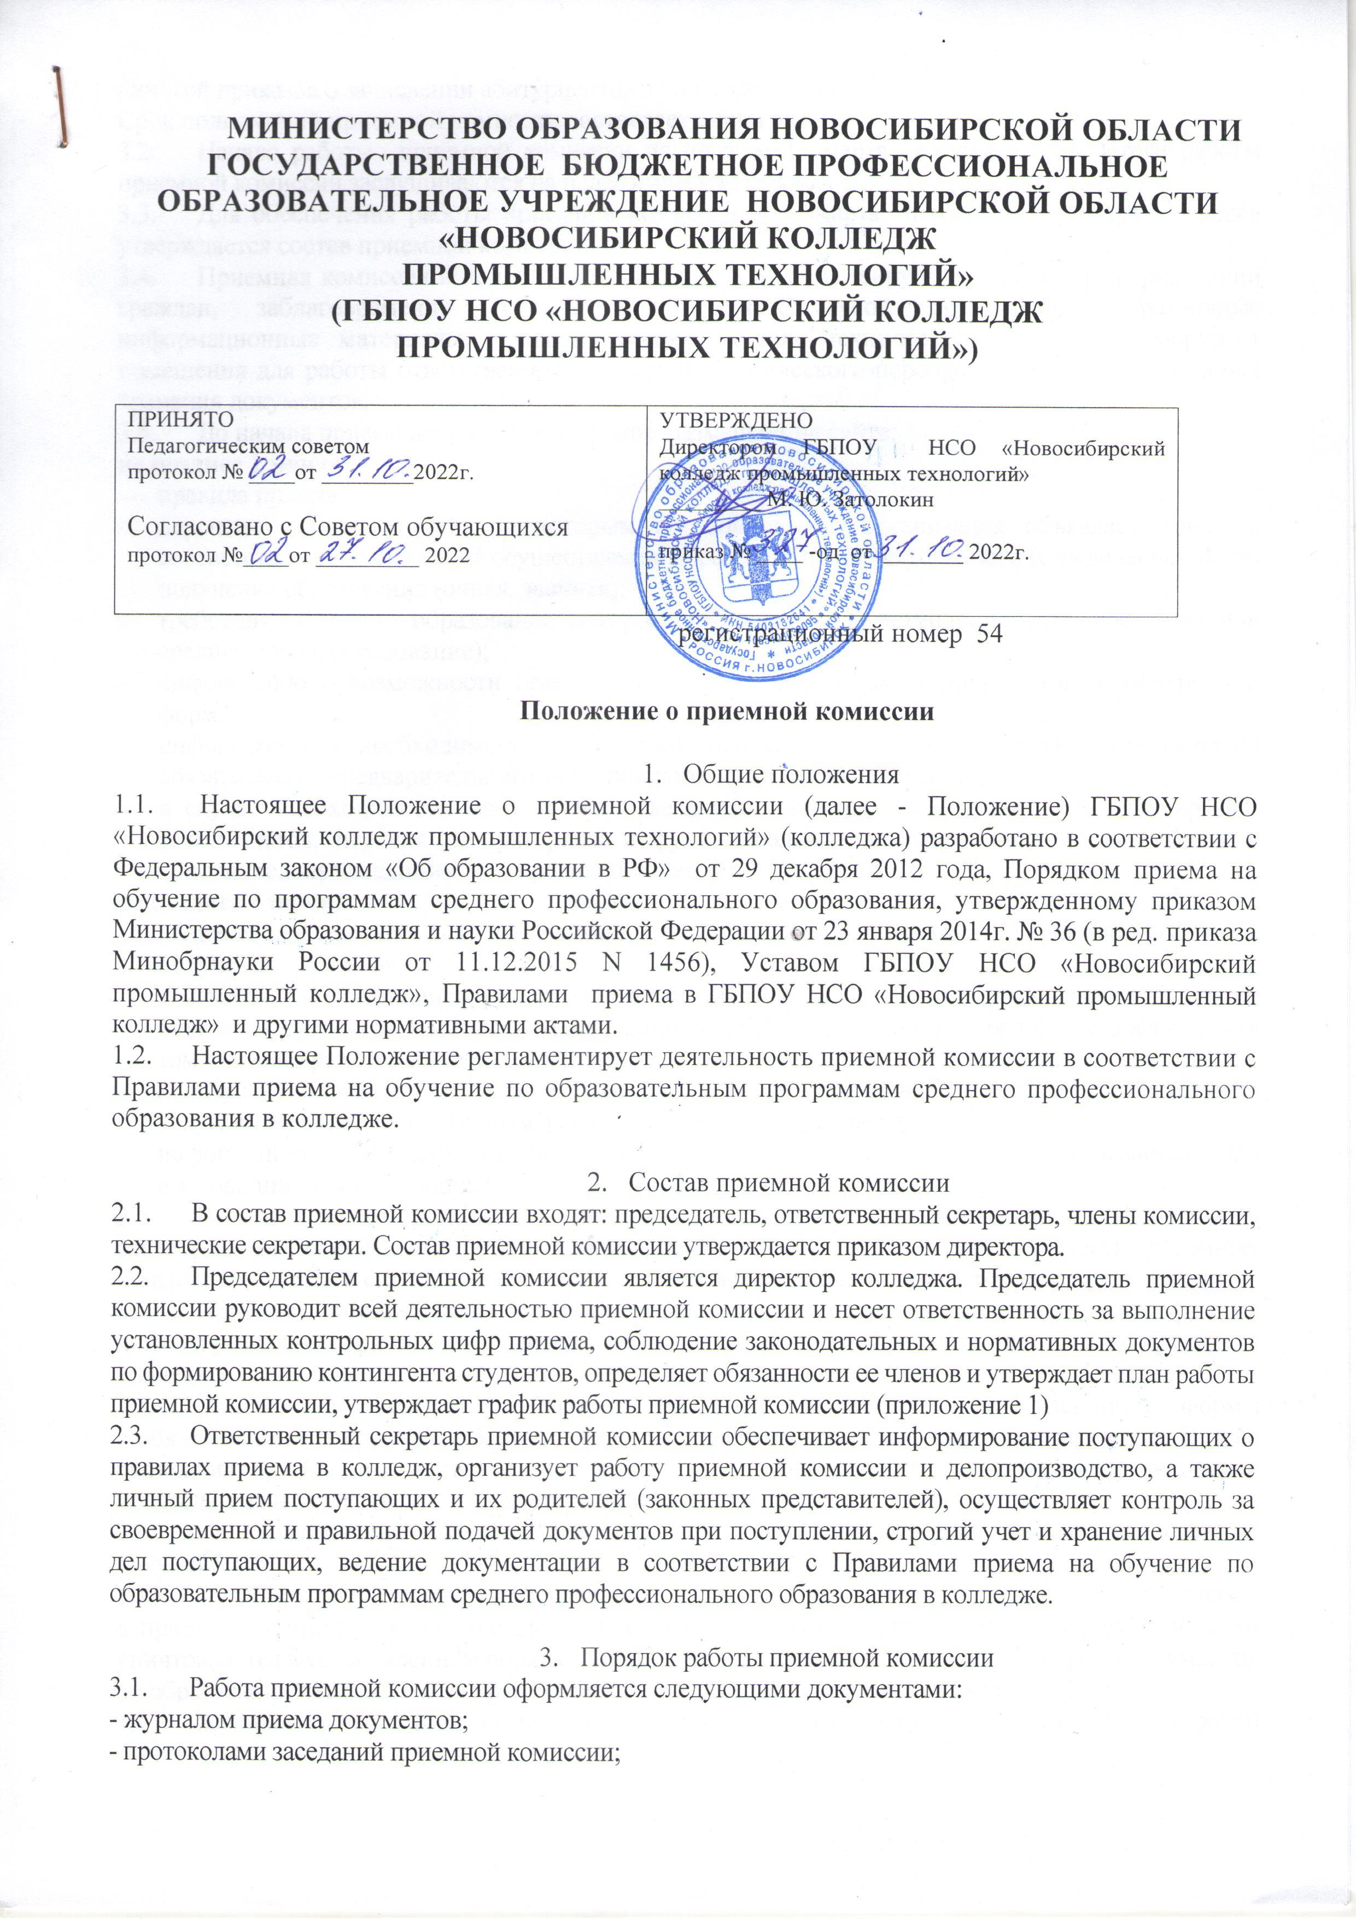

C:\Users\User\Pictures\2022-11-15\54-1.TIF

C:\Users\User\Pictures\2022-11-15\54-2.TIF